


VISVESVARAYATECHNOLOGICAL UNIVERSITY
JNANA SANGAMA, BELAGAVI - 590018

INDUSTRY INTERNSHIP REPORT ON
“Data Analytics and AI”
Submitted in partial fulfillment of requirements for the course
INDUSTRY INTERNSHIP [BINT803B]
of Eight Semester of Bachelor of Engineering in CSE- Data Science
During the academic year 2025-26.
Submitted By: Milan Nanjappa S 4MH22CD029

Under the Guidance of: Mr. Chandrashekara M S Asst. Professor,
Dept. of CSE-DS, MIT Mysore

DEPARTMENT OF CSE-Data Science

MAHARAJA INSTITUTE OF TECHNOLOGY MYSORE
BELAWADI, NAGUVANAHALLY POST, S.R. PATNA TALUK, MANDYA DISTRICT-571477
2025-2026



DEPARTMENT OF CSE-DATA SCIENCE

MAHARAJA INSTITUTE OF TECHNOLOGY MYSORE

MANDYA-571477

CERTIFICATE
Certified that this Internship Report is an Original Report of work done by me under the guidance of Prof. Chandrashekara M S and Internship Mentor/Supervisor Mr. Mahidara S and under the Supervision of Internship Supervisor (Industry) Mr. Milan Nanjappa S submitted as a part of the Internship Course [Industry Internship (BINT803B)] of Undergraduate Programme of Visvesvaraya Technological University, Jnana Sangama, Belagavi - 590018

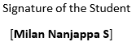
Date: Signature of the Student

Signature of the Internship Supervisor

External Viva – Voce

Name of the Examiners Signature with Date

1.

2.



DECLARATION

I MILAN NANJAPPA S (4MH22CD029) studying in the 8th semester CSE – Data Science, Maharaja Institute of Technology Mysore hereby declare that the Industry Internship entitled “DATA ANALYTICS and AI” have been carried out under the Co-ordination of Prof. Chandrashekara M S, Assistant Professor, Department CSE- Data Science, Maharaja Institute of Technology Mysore. This Industry Internship Report is submitted to the Visvesvaraya Technological University (VTU), Belagavi in partial fulfilment of the requirement for the award of the degree of Bachelor of Engineering in CSE-Data Science during the academic year 2025-26.
I also declare that, to the best of my knowledge and belief, the matter embodied in this Industry Internship Report has not been submitted previously by us for the award of any degree to any other university.

Place: Mandya Date:

Student Name USN Signature

Milan Nanjappa S 4MH22CD029

ACKNOWLEDGEMENT
It is my privilege to express gratitude and respect to all those who guided me in the completion of the Industry Internship Report.
Apart from the sheer effort, the enlightenment of the very experienced teachers also plays a paramount role because it is them who guided me in the right direction.
I am highly indebted to our beloved Principal Dr. Murali S, Principal, MIT Mysore
for giving opportunity to do the Industry Internship.
I’m extremely grateful to our beloved Incharge HoD Prof. Srikanth Bharadwaj M K, Department of Computer Science and Engineering (Data Science), MIT Mysore for his valuable guidance, constant encouragement, and support throughout the successful completion of the Industry Internship.
I place my heartfelt thanks to Mr. Chandrashekara M S, Assistant Professor, Department of Computer Science and Engineering (Data Science), MIT Mysore for Coordinating the Industry Internship.
I place my heartfelt thanks to Mr.Mahidara S, Technical Head, Incanto Dynamics, Rajajinagar, Bengaluru for guiding the Industry Internship.
I also place my heartfelt thanks to Dr. Akshath M J, Associate Professor, Department of Computer Science and Engineering, MIT Mysore for being SPOC of the Industry Internship.
I thank Visvesvaraya Technological University (VTU), Belagavi for providing me with this opportunity to do the Industry Internship.
I also thank Incanto Dynamics, Rajajinagar, Bengaluru, Karnataka for providing me with this golden opportunity to do the internship on the topic DATA ANALYTICS and AI which helped me in upskilling and learning new things.
I would like to thank all the teaching and non-teaching faculties of the Institution. I extend a very hearty thanks to my parents and friends for all the moral support they provided during the preparation for this work.

MILAN NANJAPPA S 4MH22CD029

ABSTRACT

This internship report presents the work carried out during my internship at Digital Maven (Unit of Incanto Dynamics Pvt. Ltd.) in the domains of Data Science, Artificial Intelligence, Machine Learning, Natural Language Processing, and Business Intelligence. The internship focused on the development of real-world intelligent solutions through two major industry-oriented projects: Manufacturing Throughput & Capacity Stability Analytics and Fake News Detection using NLP & Artificial Intelligence.
The primary objective of the internship was to gain practical exposure to real-world Data Science and AI applications and to understand how intelligent systems are designed, developed, tested, optimized, and deployed in a professional environment. The internship aimed to bridge the gap between academic learning and industry practices by providing hands-on experience in structured analytics, predictive modeling, intelligent text classification, explainable AI, and deployment workflows.
During the internship, I worked on industrial data analytics workflows involving structured manufacturing datasets, data preprocessing, SQL-based analytical processing, feature engineering, predictive forecasting, anomaly detection, and dashboard visualization. This project provided practical understanding of how data-driven analytics can be applied to monitor production performance, identify operational inefficiencies, and support intelligent industrial decision-making.
In addition, I worked on an AI-powered Fake News Detection project involving Natural Language Processing, machine learning classification, transformer-based architectures, explainable AI techniques, and web application deployment. This included text preprocessing, TF-IDF feature engineering, implementation of classification models, exploration of advanced NLP architectures such as BERT and RoBERTa, and integration of LIME for prediction interpretability.
The internship also provided practical exposure to modern tools and technologies including Python, SQL, Excel, Power BI, Scikit-learn, Transformers, PyTorch, LIME, Gradio, Git, Jupyter Notebook, Google Colab, BeautifulSoup, and Requests, along with structured workflows for testing, debugging, performance evaluation, dashboard development, and intelligent application deployment.
Overall, the internship significantly enhanced my technical, analytical, problem-solving, and professional skills by providing practical experience in solving real-world industrial and AI-driven problems. It served as a valuable learning experience that strengthened my readiness for future opportunities in Data Science, Machine Learning, Artificial Intelligence, Natural Language Processing, Analytics, and intelligent software development.

CERTIFICATE ii
DECLARATION iv
ACKNOWLEDGEMENT v
ABSTRACT vi
TABLE OF CONTENT vii
LIST OF FIGURES ix
ABOUT THE ORGANIZATION 1
  - Organization Overview 1
  - Project Components 2
  - Application Architecture 3
  - Organizational Ecosystem 4
INTRODUCTION 5
INTERNSHIP PLANNING AND METHODOLOGY 7
OBJECTIVES OF INTERNSHIP 16
LEARNING EXPERIENCE 19
  - Overview of Learning Experiences 19
  - Artificial Intelligence and Machine Learning Experience 19
  - Data Collection and Preprocessing 21
  - AI Workflow and System Integration 22
  - Database Handling and Data Management 24
  - Intelligent Analytics and AI-Based Decision Support Systems 25
  - Debugging and Problem Solving 27
  - Testing Experience 28
  - Domain Knowledge and Practical Analytical Understanding 29
  - UI/UX Enhancements 30
  - Learning Modern Tools and Technologies 31
  - Team Collaboration and Communication 33
  - Real-Time Project Workflow 33
LEARNING OUTCOMES 35

SNAPSHOTS 38
FUTURE SCOPE 44
CONCLUSION 47
REFERENCES 49
ATTACHMENTS 51

Figure 1.1: Incanto Dynamics 1
Figure 6.3: Data Pipeline 22
Figure 6.4: AI Workflow 24
Figure 6.6: Workflow 27
Figure 8.1: Dataset 38
Figure 8.2: Excel Dashboard 1 38
Figure 8.3: Excel Dashboard 2 39
Figure 8.4: SQL Anlysis 1 39
Figure 8.5: SQL Analysis 2 40
Figure 8.6: Python Analysis 40
Figure 8.7: Power BI Dashboard 1 41
Figure 8.8: Powe BI Dashboard 2 41
Figure 8.9: Fake news detection - Training TF-TDF 42
Figure 8.10: Fake news detection - Training SVM 42
Figure 8.11: Fake news detector UI 43

CHAPTER 1

ABOUT THE ORGANIZATION

Organization Overview
Incanto Dynamics Pvt. Ltd. is a Bangalore-based technology and consulting company specializing in industrial automation, robotics, and advanced technological training. The company is located in Rajajinagar, Bengaluru, and is recognized for providing hands-on training and real-world project experience in automation and intelligent systems.
It is an ISO 9001:2015 certified and DPIIT-recognized organization that focuses on delivering practical knowledge in areas such as PLC programming, industrial robotics, embedded systems, and IoT.
The company aims to bridge the gap between academic learning and industrial requirements by offering project-based learning and industry-relevant training. It is supported by experienced professionals who provide guidance based on real-time industrial projects.
Incanto Dynamics also contributes to innovation by working on automation solutions, robotics applications, and manufacturing technologies such as customized drones and RC systems.
The organization operates with a strong focus on Industry 5.0 concepts, integrating human intelligence with automation and smart systems, preparing students and professionals for future technological advancements.


Figure 1.1: Incanto Dynamics

Project Components
Industrial Data Analytics Workflow Integration: A complete data analytics workflow was implemented for the manufacturing analytics project, integrating data preprocessing, exploratory analysis, SQL-based data engineering, predictive modeling, and dashboard visualization. This workflow enabled systematic analysis of industrial production data, helping automate performance monitoring, anomaly detection, and forecasting tasks.
Manufacturing Data Management and Processing: A structured approach was followed to manage and process manufacturing datasets containing machine performance and operational parameters. This included organizing raw production data, cleaning inconsistencies, handling missing values, feature engineering, aggregating data using SQL queries, and preparing analytical datasets for forecasting and classification tasks. Proper data management ensured reliable model performance and meaningful analytical insights.
Predictive Analytics and Intelligent Decision Support: Machine learning models were developed to support predictive industrial analytics. This included forecasting future production trends for different plants and detecting low-output operational events using classification techniques. These predictive systems helped simulate intelligent decision- making for preventive maintenance and production optimization.
Natural Language Processing-Based Fake News Detection System: An AI-powered text classification system was developed to automatically detect fake and real news articles. The system used Natural Language Processing (NLP) techniques to preprocess text, extract features, and classify articles using machine learning models. This enabled automated misinformation detection through intelligent text analysis.
Transformer-Based AI Architecture and Explainable AI Integration: Advanced AI architectures such as BERT and RoBERTa were implemented as part of the fake news detection workflow to understand modern deep learning approaches in NLP. Additionally, Explainable AI techniques using LIME were integrated to make model predictions transparent by highlighting influential words and phrases, improving interpretability and trustworthiness.
Web-Based AI Application Deployment: A web-based interactive fake news detection application was developed using Gradio. The system allowed users to input article text or provide URLs for live classification, confidence scoring, and explainable prediction outputs. This provided practical exposure to deploying AI models into real-world user-facing applications.

Semantic Text Processing and Intelligent Content Analysis: Text preprocessing and intelligent feature engineering techniques were applied to convert unstructured textual news content into machine-readable representations using TF-IDF vectorization and NLP pipelines. This enabled meaningful classification, contextual analysis, and efficient machine learning- based decision-making.

Application Architecture
The application followed a data-driven AI architecture, where:

    - Machine Learning and NLP models handled intelligent classification, predictive analysis, and automated decision-making tasks.
    - Python-based analytics libraries and AI frameworks were used for data preprocessing, feature engineering, machine learning model development, NLP implementation, and workflow automation.
    - Structured manufacturing datasets and unstructured textual datasets were integrated for industrial analytics and fake news classification workflows.
    - SQL-based data engineering and analytical table creation were used for efficient data extraction, aggregation, and structured processing in the manufacturing analytics pipeline.
    - TF-IDF feature engineering, machine learning classifiers, transformer architectures, and explainable AI mechanisms were used to enable intelligent content classification and interpretable predictions.
    - Power BI dashboards and Gradio web deployment were used for interactive visualization, monitoring, and real-time user interaction with AI-based systems.
The platform supports real-time analytical processing, predictive modeling, intelligent classification, and interactive decision support. It is designed to:
    - Improve manufacturing monitoring efficiency through throughput analysis, forecasting, anomaly detection, and machine stability insights.
    - Reduce manual analytical effort by automating data preprocessing, predictive modeling, and performance monitoring workflows.

    - Enhance misinformation detection through AI-powered fake news classification, explainable prediction analysis, and real-time article verification.
    - Provide scalable, intelligent decision-support systems using modern Data Science, Machine Learning, NLP, dashboard analytics, and web deployment technologies.

Organizational Ecosystem
Digital Maven, a unit of Incanto Dynamics Pvt. Ltd., operates with a team of skilled professionals including data analysts, software developers, AI/ML engineers, business intelligence specialists, and technology experts focused on building real-world data-driven solutions. During the internship, exposure to this professional environment provided valuable insight into how multidisciplinary teams collaborate to design, develop, and deploy practical analytics and AI-based systems for industry applications. The organization’s focus on modern technologies such as Data Science, Artificial Intelligence, Machine Learning, predictive analytics, NLP, and dashboard-based business intelligence reflects its strong alignment with current industry demands and emerging technological advancements.
The internship period provided practical exposure to how Data Science and Artificial Intelligence solutions are developed, implemented, and optimized in a real-world industrial environment. Working on end-to-end projects involving industrial analytics, machine learning, natural language processing, explainable AI, and deployment offered a highly valuable professional learning experience. Contributing independently to industry-oriented projects significantly enhanced my technical knowledge, problem-solving abilities, and understanding of real-world AI application development workflows.

CHAPTER 2

INTRODUCTION

The provided internship report details a comprehensive professional experience at VisionAstraa EV Academy, an organization at the forefront of integrating Artificial Intelligence (AI) and Machine Learning (ML) with Electric Vehicle (EV) technology. This forward-thinking academy is dedicated to bridging the critical gap between theoretical academic learning and the practical, rapidly evolving requirements of the modern industrial landscape. By providing hands-on project experience and technical skill development, the organization empowers engineers with the multidisciplinary tools necessary to excel in the EV and AI sectors.
The central focus of this internship was the development of an AI-powered EV Diagnostic Assistant, an intelligent system engineered to help technicians, students, and enthusiasts diagnose vehicle issues using natural language. This project utilized sophisticated Retrieval- Augmented Generation (RAG) techniques to ensure that the AI's responses were grounded in authoritative technical datasets, such as manufacturer service manuals and specification sheets. By integrating AI and ML concepts, the assistant automates complex data processing and decision-making tasks, significantly improving troubleshooting efficiency and reducing the manual effort required for vehicle maintenance.
The architecture of the application followed a robust full-stack model, where Python-based AI frameworks and machine learning models handled the core intelligent analysis. A vital component of this system was ChromaDB, an open-source vector database used to manage high-dimensional embeddings for efficient semantic search. Unlike traditional keyword-based searches, this semantic approach allowed the system to understand the underlying intent and context of user queries, returning the most relevant diagnostic information or troubleshooting steps in plain language.

Beyond software development, the internship provided deep exposure to EV systems, including battery management systems (BMS), charging protocols, and fault code diagnostics. This domain knowledge was essential for ensuring the AI system could accurately interpret technical data and provide actionable advice. Furthermore, the experience emphasized the importance of a professional development lifecycle, encompassing data preprocessing, system validation through rigorous testing, and UI/UX enhancements to ensure the platform remained intuitive for end-users.
Ultimately, this internship served as a transformative bridge between classroom theory and professional practice. By contributing to a live product within a multidisciplinary team of engineers and researchers, the participant gained not only technical proficiency in AI and EV technologies but also vital professional skills in teamwork, communication, and systematic problem-solving. This holistic experience underscores the growing importance of intelligent systems in shaping a sustainable future for electric mobility.

CHAPTER 3

INTERNSHIP PLANNING AND METHODOLOGY

The internship at Digital Maven (Unit of Incanto Dynamics Pvt. Ltd.) followed a structured methodology focused on developing real-world Data Science and AI solutions through two major projects: Manufacturing Throughput & Capacity Stability Analytics and Fake News Detection using NLP & AI. The approach involved data collection, preprocessing, feature engineering, exploratory analysis, predictive modeling, visualization, explainability, deployment, and performance evaluation. The manufacturing project included industrial data analysis using Excel, SQL, Python, machine learning, and Power BI dashboards, while the fake news project involved NLP preprocessing, machine learning classification, transformer architecture implementation, LIME-based explainability, and Gradio web deployment. This methodology provided practical exposure to the complete lifecycle of modern AI and data- driven solution development.

Project Planning and Objectives

The internship was planned around two major industry-oriented projects designed to bridge the gap between academic learning and real-world implementation in Data Science and Artificial Intelligence. The planning focused on developing practical solutions for industrial analytics and intelligent text classification using modern AI technologies.

  - Objective Alignment: Initial planning involved defining the scope of both projects, including manufacturing performance analysis through predictive analytics and fake news detection through NLP-based intelligent classification. The objective was to apply data-driven methodologies for solving real-world industrial and information-centric problems.

  - System Architecture Design: The projects were planned using structured end-to-end workflows. The manufacturing analytics project was designed as a data analytics pipeline involving Excel analysis, SQL engineering, machine learning models, and Power BI dashboards, while the fake news detection project followed an AI application architecture involving data preprocessing, NLP feature engineering, machine learning classification, explainable AI integration, and Gradio-based web deployment..

Methodology: Throughput and Capacity Stability Analysis
The methodology for the Manufacturing Throughput & Capacity Stability Analytics project was designed as a structured data analytics and machine learning workflow aimed at analyzing industrial production performance, forecasting future output, and detecting operational anomalies.
  - Data Collection and Preprocessing: The project began with working on a structured manufacturing dataset containing production metrics, machine operational parameters, maintenance records, defect counts, and energy consumption data. Initial preprocessing involved organizing the dataset, cleaning inconsistencies, extracting relevant features such as date and hourly information, and preparing the data for analysis.
  - Exploratory Data Analysis and Performance Assessment: Excel-based analysis was performed to study hourly throughput trends, identify peak and low production periods, calculate utilization metrics, and evaluate machine stability using statistical measures such as mean, standard deviation, and coefficient of variation.
  - SQL-Based Data Engineering: SQL was used to perform structured data aggregation, including hourly and daily production summaries, identification of low-performing machines, and creation of analytical warehouse tables for efficient performance analysis and reporting.
  - Predictive Modeling and Anomaly Detection: Machine learning techniques were implemented to forecast plant-wise production trends and classify low-output operational events. Forecasting models were used for production prediction, while a Random Forest classifier combined with SMOTE and preprocessing techniques was used for anomaly/event detection.
  - Dashboard Development and Visualization: Interactive Power BI dashboards were developed to visualize production trends, plant performance comparisons, machine stability metrics, maintenance impact, and operational KPIs, enabling effective monitoring and data- driven decision-making.

Methodology: Fake News Detection
The methodology for the Manufacturing Throughput & Capacity Stability Analytics project was designed as a structured data analytics and machine learning workflow aimed at analyzing industrial production performance, forecasting future output, and detecting operational anomalies.
  - Data Collection and Preprocessing: The project began with working on a structured manufacturing dataset containing production metrics, machine operational parameters, maintenance records, defect counts, and energy consumption data. Initial preprocessing involved organizing the dataset, cleaning inconsistencies, extracting relevant features such as date and hourly information, and preparing the data for analysis.
  - Exploratory Data Analysis and Performance Assessment: Excel-based analysis was performed to study hourly throughput trends, identify peak and low production periods, calculate utilization metrics, and evaluate machine stability using statistical measures such as mean, standard deviation, and coefficient of variation.
  - SQL-Based Data Engineering: SQL was used to perform structured data aggregation, including hourly and daily production summaries, identification of low-performing machines, and creation of analytical warehouse tables for efficient performance analysis and reporting.
  - Predictive Modeling and Anomaly Detection: Machine learning techniques were implemented to forecast plant-wise production trends and classify low-output operational events. Forecasting models were used for production prediction, while a Random Forest classifier combined with SMOTE and preprocessing techniques was used for anomaly/event detection.
  - Dashboard Development and Visualization: Interactive Power BI dashboards were developed to visualize production trends, plant performance comparisons, machine stability metrics, maintenance impact, and operational KPIs, enabling effective monitoring and data- driven decision-making.

3.3 Methodology – Fake News Detection using NLP & AI Project
The methodology for the Fake News Detection using NLP & AI project was designed as an end-to-end intelligent text classification workflow aimed at automatically identifying fake and real news articles using machine learning, natural language processing, and explainable AI techniques.
- Data Collection and Preprocessing: The project began with working on the ISOT Fake News dataset, containing labeled real and fake news articles. Initial preprocessing involved text cleaning, normalization, removal of irrelevant content, handling dataset inconsistencies, Reuters leakage removal, and preparation of structured training, validation, and test datasets.
- Feature Engineering and NLP Processing: Natural Language Processing techniques were applied to convert raw textual data into machine-readable representations. TF-IDF vectorization was used for feature extraction, enabling efficient representation of textual content for machine learning classification.
- Machine Learning and Transformer Model Development: Multiple classification models were implemented, including Logistic Regression and Linear Support Vector Machine (SVM) as baseline machine learning models, along with transformer-based architectures such as BERT and RoBERTa for advanced NLP experimentation and intelligent text understanding.
- Explainable AI Integration: Explainability techniques using LIME (Local Interpretable Model-Agnostic Explanations) were integrated to improve transparency by highlighting influential words and phrases contributing to fake or real news predictions.
- Web Application Deployment and User Interaction: A user-interactive web application was developed using Gradio, enabling users to input article text or provide news URLs for real- time classification, confidence scoring, article content extraction, and explainable prediction outputs.

Domain-Specific Methodology: Industry Analytics and Fake News Detection

The internship projects integrated domain-specific knowledge in industrial manufacturing analytics and intelligent text classification to ensure practical real-world applicability. The methodology included studying:

  - Manufacturing Performance Analytics: Understanding key industrial performance metrics such as throughput, machine stability, capacity utilization, maintenance frequency, defect trends, and energy consumption to analyze production efficiency and support predictive decision-making.
  - Predictive Maintenance and Anomaly Detection: Mapping machine operational behavior, sensor patterns, and low-output events to predictive analytics workflows in order to identify anomalies, detect performance degradation, and support preventive maintenance strategies.
  - Natural Language Processing for Text Classification: Understanding text preprocessing techniques, feature engineering methods, and machine learning-based text classification approaches to accurately distinguish between fake and real news content.
  - Explainable AI and Intelligent Decision Support: Integrating explainability concepts through LIME to identify influential words and phrases contributing to classification decisions, improving transparency and interpretability of AI-generated outputs.
  - Debugging and Optimization Protocol: A systematic debugging approach was followed to resolve issues related to data preprocessing, SQL query execution, model performance limitations, dependency conflicts, NLP preprocessing errors, transformer environment setup, and deployment-related challenges. Model tuning and preprocessing refinements were performed to improve accuracy and system efficiency.

Multi-Tiered Testing:

    - Manual Testing: Both projects were tested manually by validating analytical outputs, dashboard visualizations, classification predictions, forecasting results, anomaly detection performance, and fake news prediction workflows under different scenarios.

    - Model Performance Testing: Machine learning models were evaluated using appropriate performance metrics such as Accuracy, Precision, Recall, F1 Score, and MAPE to assess forecasting accuracy and classification effectiveness.

    - Dashboard and User Interface Optimization: The final phase included refining Power BI dashboards for clear industrial performance visualization and improving the

Gradio web application interface for better user interaction, confidence score presentation, explainability output, and responsive usability.
Through this structured planning, technical implementation, testing, and optimization methodology, the internship successfully delivered intelligent data-driven solutions for industrial analytics and fake news detection, reducing manual analytical effort, improving decision-making efficiency, and demonstrating practical real-world AI application development.

CHAPTER 4
TECHNICAL LEARNING
Based on the internship at Digital Maven (Unit of Incanto Dynamics Pvt. Ltd.), the technical learning was centered on the practical application of Data Science, Machine Learning, Artificial Intelligence, Natural Language Processing, Industrial Analytics, and Explainable AI. The following sections detail the core technical competencies acquired:

Data Science & Machine Learning Frameworks

  - Machine Learning Model Development: Gained practical experience in designing, training, and evaluating machine learning models for forecasting, anomaly detection, and text classification using algorithms such as Random Forest, Logistic Regression, and Support Vector Machines (SVM).
  - Predictive Analytics: Learned how predictive models are applied in real-world industrial scenarios for production forecasting, low-output event detection, and operational performance monitoring.
  - Transformer-Based AI Architectures: Developed understanding of modern NLP architectures such as BERT and RoBERTa, including their role in advanced language understanding and intelligent text classification.
  - Model Evaluation Techniques: Gained practical knowledge in evaluating machine learning models using performance metrics such as Accuracy, Precision, Recall, F1 Score, and Mean Absolute Percentage Error (MAPE).

Data Engineering & Preprocessing

  - Structured Data Processing: Learned to work with real-world industrial datasets involving production, maintenance, defect, sensor, and operational parameters through cleaning, transformation, feature extraction, and structured analytical preparation.
  - Text Data Preprocessing: Practiced NLP preprocessing techniques including text cleaning, normalization, removal of irrelevant content, dataset leakage handling, and feature engineering for machine learning-based classification.

  - Feature Engineering: Developed practical knowledge in preparing data for model training using statistical features, derived operational metrics, and TF-IDF vectorization for text classification.

SQL Engineering & Data Analytics

  - SQL Query Development: Gained practical experience in writing SQL queries for data extraction, filtering, aggregation, grouping, sorting, and analytical table creation.
  - Data Aggregation & Reporting: Learned how to generate hourly, daily, and machine-level performance summaries for industrial analytics workflows.
  - Analytical Data Structuring: Understood the importance of structured data engineering for supporting predictive modeling, dashboard reporting, and efficient business analysis.

Industrial Analytics & Business Intelligence

  - Manufacturing Performance Analytics: Acquired practical knowledge in analyzing industrial metrics such as throughput, capacity utilization, machine stability, defect trends, maintenance impact, and operational efficiency.
  - Dashboard Development: Developed interactive dashboards using Power BI, including KPI cards, trend charts, comparative analytics, and performance monitoring visualizations.
  - Decision Support Systems: Learned how industrial analytics can support operational monitoring, predictive maintenance, and data-driven decision-making.

Natural Language Processing & Explainable AI

  - Text Classification Systems: Gained hands-on experience in designing intelligent fake news detection systems using NLP pipelines and machine learning models.
  - Explainable AI (XAI): Learned to integrate LIME (Local Interpretable Model-Agnostic Explanations) for improving model transparency by highlighting influential words and phrases in predictions.
  - Intelligent Content Analysis: Developed understanding of how AI systems process unstructured text and perform automated classification for real-world applications.

Deployment, Development Tools & Testing

  - Web Application Deployment: Developed practical exposure to deploying machine learning solutions through Gradio-based interactive web applications.
  - Development Tools: Used Python, Jupyter Notebook, Google Colab, VS Code, Git, Power BI, Excel, and SQL environments for end-to-end project implementation.
  - System Validation & Testing: Performed manual testing, debugging, preprocessing validation, dashboard verification, and model performance testing to ensure solution reliability and accuracy.

Problem Solving & End-to-End Project Development

  - Full Project Lifecycle Understanding: Gained practical experience in complete project execution, including planning, data collection, preprocessing, modeling, visualization, deployment, documentation, and presentation.
  - Analytical Thinking & Debugging: Strengthened problem-solving ability through handling real-world technical issues such as data inconsistencies, model optimization, dependency conflicts, and deployment challenges.
  - Industry-Oriented Solution Development: Learned how theoretical academic concepts are transformed into practical, scalable, and user-oriented AI and analytics solutions.

CHAPTER 5

OBJECTIVES OF INTERNSHIP

The primary objective of this internship was to gain practical exposure to Data Science, Artificial Intelligence, Machine Learning, Natural Language Processing, Business Intelligence, and real-world analytics solution development in a professional environment. The internship was structured around multiple objectives focused on technical skill development, practical problem-solving, and industry-oriented implementation through two major projects: Manufacturing Throughput & Capacity Stability Analytics and Fake News Detection using NLP & AI.

Objective 1: To Understand Real-World Data Science and AI Applications

The foremost objective of the internship was to gain hands-on experience in understanding how Data Science and AI solutions are implemented in real-world industrial and information-centric applications. While academic learning focuses on theoretical algorithms and concepts, real- world implementations involve data engineering challenges, system integration, model evaluation, deployment considerations, and performance optimization. Through this internship, I gained direct exposure to how practical AI systems are developed to solve real business and analytical problems.

Objective 2: To Gain Practical Exposure to End-to-End Data Analytics Workflows

A key objective was to understand the complete lifecycle of data analytics workflows, including data collection, preprocessing, exploratory analysis, feature engineering, predictive modeling, dashboard visualization, and reporting. This objective was achieved through the manufacturing analytics project, where I worked with industrial datasets to derive meaningful insights and build intelligent decision-support systems.

Objective 3: To Develop Strong Data Preprocessing and Feature Engineering Skills

Data preprocessing is one of the most critical stages in any data science project. The internship aimed to provide practical exposure to handling real-world structured and unstructured datasets, including data cleaning, transformation, normalization, feature extraction, text

preprocessing, and preparation of model-ready datasets. This objective was achieved through both industrial analytics and NLP-based project workflows.

Objective 4: To Gain Experience in SQL-Based Data Engineering and Analytical Processing
Another major objective was to strengthen practical knowledge of SQL for data extraction, filtering, aggregation, analytical table creation, and structured reporting. SQL plays a critical role in industrial analytics workflows, and this internship provided hands-on experience in writing efficient SQL queries to process and analyze manufacturing data.
Objective 5: To Understand Predictive Analytics and Machine Learning Model Development

The internship aimed to provide practical exposure to designing, training, and evaluating machine learning models for forecasting, anomaly detection, and classification tasks. This included implementing predictive analytics for industrial production forecasting and low- output event detection, as well as classification models for fake news detection.

Objective 6: To Gain Practical Knowledge in Natural Language Processing (NLP)

As part of the fake news detection project, a major objective was to understand Natural Language Processing workflows for handling textual data. This included text preprocessing, feature engineering using TF-IDF vectorization, machine learning-based text classification, and the implementation of intelligent text analysis systems.

Objective 7: To Learn Advanced AI Architectures and Explainable AI Concepts

The internship aimed to provide exposure to modern AI architectures such as BERT and RoBERTa, along with Explainable AI techniques such as LIME. Understanding advanced NLP architectures and model interpretability is an important industry skill, and this objective was fulfilled through hands-on implementation and experimentation.

Objective 8: To Develop Dashboard Visualization and Business Intelligence Skills

A key objective was to understand how data insights are communicated through effective visual analytics. This involved learning dashboard development using Power BI, creating KPI-based reports, interactive charts, comparative analysis dashboards, and performance monitoring visualizations.

Objective 9: To Gain Experience in AI Application Deployment

Building AI models alone is not sufficient unless they can be deployed for practical use. This internship aimed to provide practical knowledge in deploying AI solutions through user- interactive applications. This objective was achieved through the development of the Gradio- based fake news detection web application.

Objective 10: To Improve Debugging, Testing, and Problem-Solving Skills

A major professional objective was to improve systematic debugging and technical problem- solving skills. Real-world projects involved issues related to preprocessing errors, model performance limitations, dependency conflicts, SQL debugging, dashboard refinement, and deployment challenges, all of which strengthened my analytical troubleshooting capabilities.

Objective 11: To Gain Practical Exposure to Modern Industry Tools and Technologies

The internship provided hands-on experience with tools and technologies widely used in industry, including Python, SQL, Excel, Power BI, Scikit-learn, Transformers, PyTorch, Jupyter Notebook, Google Colab, Git, LIME, and Gradio. This significantly improved my practical industry readiness.

Objective 12: To Bridge the Gap Between Academic Learning and Real-World Industry Practices
The overarching objective of the internship was to apply theoretical academic knowledge in real-world project environments and develop industry-level technical competence. The internship successfully bridged the gap between classroom concepts and practical implementation by providing end-to-end exposure to modern Data Science and AI solution development.

CHAPTER 6

LEARNING EXPERIENCE

Overview of Learning Experiences
During the internship at Digital Maven (Unit of Incanto Dynamics Pvt. Ltd.), I gained practical exposure to Data Science, Machine Learning, Artificial Intelligence, Natural Language Processing, Business Intelligence, and real-world analytics solution development through two major industry-oriented projects: Manufacturing Throughput & Capacity Stability Analytics and Fake News Detection using NLP & AI. The learning experience extended beyond theoretical technical concepts to include real-world data engineering workflows, predictive analytics, dashboard development, machine learning model implementation, explainable AI integration, deployment practices, debugging, and performance evaluation. Each project provided a unique and complementary learning experience—one focused on industrial analytics and predictive decision support, and the other on intelligent text classification and AI- based application development—collectively helping build a strong, well-rounded technical foundation aligned with modern Data Science and AI industry practices.

Artificial Intelligence and Machine Learning Experience
One of the most significant aspects of the internship was gaining practical knowledge in Artificial Intelligence, Machine Learning, Predictive Analytics, and Natural Language Processing through real-world project implementation. In academic environments, AI and machine learning are often taught through theoretical models, isolated algorithms, and benchmark datasets. In contrast, during the internship at Digital Maven (Unit of Incanto Dynamics Pvt. Ltd.), these technologies were applied to practical industry-oriented problems involving industrial manufacturing analytics and intelligent fake news detection, where data complexity, preprocessing challenges, model optimization, and deployment considerations played an important role.
Through the Manufacturing Throughput & Capacity Stability Analytics project, I gained practical exposure to predictive machine learning workflows involving production forecasting, anomaly detection, classification modeling, and operational performance analysis. This helped me understand how machine learning models are developed, trained, optimized, and evaluated for real-world decision-support systems.

Through the Fake News Detection using NLP & AI project, I gained hands-on experience in intelligent text classification workflows involving machine learning, NLP preprocessing, transformer-based architectures, explainable AI, and deployment. This provided practical understanding of how AI-based classification systems are designed to process unstructured text, generate predictions, and deliver interpretable outputs.
Key learning areas in this module included:

    - Understanding the practical implementation of machine learning models for forecasting, anomaly detection, and text classification.
    - Learning how different AI components such as preprocessing pipelines, feature engineering methods, classification models, transformer architectures, and explainability modules interact to form intelligent systems.
    - Gaining practical knowledge of machine learning algorithms such as Random Forest, Logistic Regression, and Support Vector Machines (SVM) for solving real-world analytical problems.
    - Understanding transformer-based NLP architectures such as BERT and RoBERTa for advanced text analysis and intelligent language understanding.
    - Learning how Explainable AI techniques such as LIME improve model transparency by highlighting influential words and phrases contributing to predictions.
    - Developing awareness of practical AI system challenges including data imbalance, preprocessing complexity, model tuning, overfitting risks, dependency conflicts, and deployment limitations.
This experience also highlighted the importance of model evaluation in AI systems, where performance must be measured using appropriate metrics such as Accuracy, Precision, Recall, F1 Score, and MAPE to ensure reliability, effectiveness, and practical usability.
Overall, this module provided a strong foundation in applying AI and machine learning concepts to solve complex real-world industry problems.

Data Collection and Preprocessing
Data forms the foundation of any Data Science, Machine Learning, and Artificial Intelligence system, and the quality of data directly impacts the reliability and performance of analytical models. During the internship, I gained extensive hands-on experience in working with both structured industrial datasets and unstructured textual datasets, making data collection and preprocessing one of the most important and practical learning components of the internship.
For the Manufacturing Throughput & Capacity Stability Analytics project, the data consisted of structured industrial operational records containing production metrics, machine details, sensor readings, maintenance events, defect counts, and energy consumption information. The preprocessing process involved organizing raw manufacturing data, identifying inconsistencies, handling missing values where necessary, extracting useful temporal features such as hourly and daily patterns, and preparing analytical datasets for forecasting, anomaly detection, and dashboard reporting.
For the Fake News Detection using NLP & AI project, the data consisted of large- scale textual datasets containing labeled real and fake news articles. Since unstructured textual data requires significant preparation before model training, preprocessing involved multiple stages including text cleaning, removal of irrelevant formatting artifacts, normalization of textual content, handling dataset inconsistencies, removal of Reuters dataset leakage, and preparation of clean train, validation, and test datasets.
The preprocessing workflow included the following key stages:

- Structured Data Preparation: Organizing manufacturing datasets, cleaning inconsistencies, extracting performance metrics, and preparing machine learning- ready analytical features.
- Text Cleaning and Normalization: Removing unwanted characters, redundant formatting, irrelevant content, and standardizing textual data for consistent NLP processing.
- Feature Engineering: Creating derived analytical features for industrial performance analysis and converting textual data into machine-readable numerical representations using TF-IDF vectorization.

- Data Structuring and Splitting: Preparing datasets in structured formats and performing appropriate train-validation-test splitting for reliable machine learning evaluation.
This end-to-end exposure to structured and unstructured data preprocessing provided a strong understanding of how critical data preparation is in building accurate, reliable, and effective Data Science and AI systems.
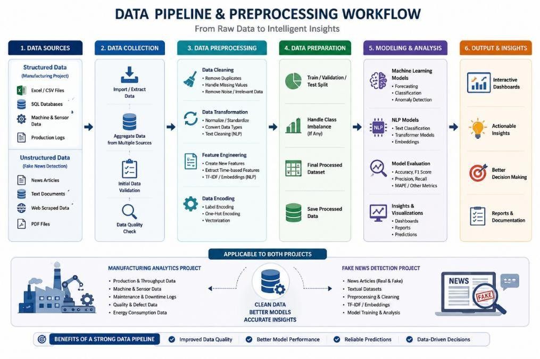
Figure 6.3: Data Pipeline

AI Workflow and System Integration
Building machine learning and AI models is only one part of developing intelligent systems; integrating them into complete analytical workflows and user-oriented applications is equally important. During the internship, I gained practical hands-on experience in integrating data processing pipelines, machine learning workflows, visualization systems, and deployment components across two real-world projects.
For the Manufacturing Throughput & Capacity Stability Analytics project, the workflow involved multiple interconnected stages beginning with raw industrial data collection, preprocessing, SQL-based analytical processing, feature engineering, predictive model implementation, anomaly detection, and dashboard visualization. Data flowed through different layers of the analytics pipeline, where structured operational records were transformed into meaningful insights for production monitoring, forecasting, and performance analysis.

For the Fake News Detection using NLP & AI project, the workflow involved an end- to-end intelligent AI pipeline where user-provided article text or news URLs were processed through preprocessing modules, converted into machine-readable representations using TF- IDF vectorization, passed through classification models for prediction, and further integrated with Explainable AI components for interpretability. The final outputs were delivered through a Gradio-based interactive web application, providing real-time classification and confidence- based responses.
Managing these multi-stage workflows required understanding data flow management, model integration, debugging, performance optimization, and system-level thinking. I worked on:
    - Designing and implementing structured data analytics and NLP-based machine learning workflows.
    - Integrating preprocessing pipelines, machine learning models, explainability modules, and user-facing interfaces.
    - Managing data flow between data sources, processing layers, analytical models, visualization dashboards, and deployment environments.
    - Implementing debugging, validation, and error handling strategies to ensure reliable analytical and prediction outputs.
    - Optimizing workflows for model performance, response efficiency, dashboard usability, and practical application delivery.
This experience emphasized the importance of viewing AI and Data Science solutions as complete integrated systems rather than isolated models, and provided practical understanding of how modern production-oriented analytics and AI applications are structured, developed, and deployed.

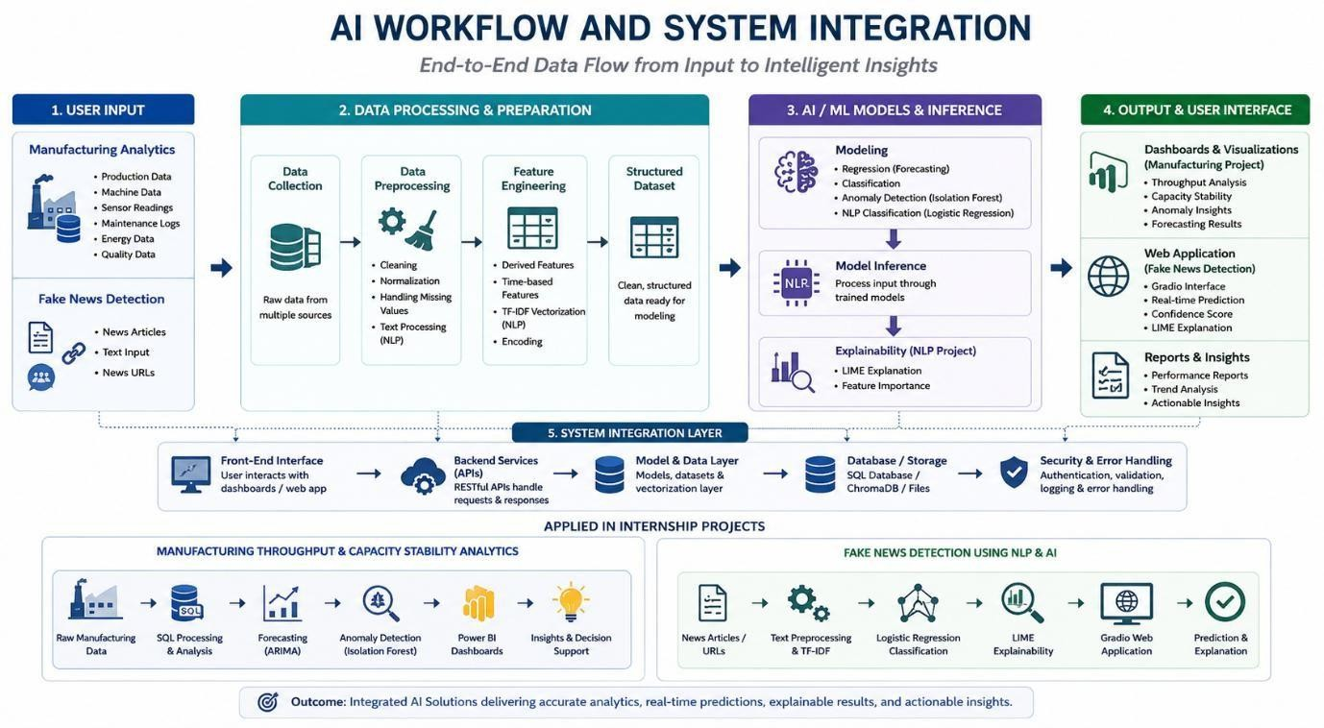

Figure 6.4: AI Workflow

Database Handling and Data Management

One of the technically significant aspects of this internship was gaining practical experience in handling both structured industrial data and machine learning-ready datasets using database technologies, analytical data processing, and structured data management workflows. Unlike AI systems that rely on vector databases for semantic retrieval, my projects involved managing structured manufacturing data, textual datasets, and processed analytical outputs required for predictive analytics and intelligent classification systems.
During the internship, I learned and practiced the following data management operations:

SQL-Based Data Management: Working extensively with SQL for extracting, filtering, aggregating, and organizing structured manufacturing datasets. I used SQL queries to generate hourly production summaries, machine-level analytics, plant performance comparisons, and analytical warehouse tables that supported forecasting and dashboard reporting.
Analytical Data Structuring: Preparing structured datasets for machine learning workflows by organizing production metrics, sensor readings, maintenance logs, defect data, and operational parameters into analysis-ready formats. This helped improve consistency, model reliability, and efficient analytical processing.

Dataset Preparation for Machine Learning: Managing processed datasets for forecasting, anomaly detection, and classification tasks by performing feature engineering, train-test splitting, normalization, and structured storage of machine learning-ready data.
Text Data Management for NLP Workflows: Handling large textual datasets for fake news detection, including organizing labeled article data, maintaining clean structured train- validation-test datasets, and preparing feature-engineered outputs such as TF-IDF representations for model training.
Data Maintenance and Validation: Ensuring dataset consistency, handling preprocessing corrections, removing irrelevant or duplicate information, validating data quality, and updating processed datasets during iterative model development.
Working with structured databases, analytical data pipelines, and machine learning- ready data management provided valuable insight into how data infrastructure supports modern Data Science and AI workflows, and highlighted the importance of organized, reliable, and scalable data handling in real-world intelligent system development.

Intelligent Analytics and AI-Based Decision Support Systems
One of the most important and technically impactful aspects of the internship was the development of intelligent data-driven systems for industrial analytics and fake news detection, where machine learning and AI were applied to solve real-world analytical and classification problems. Unlike theoretical academic exercises, these projects required designing complete workflows capable of processing data, generating predictions, and delivering meaningful outputs to end users.
The Manufacturing Throughput & Capacity Stability Analytics project functioned as an intelligent decision-support system designed to help monitor industrial production performance, identify operational inefficiencies, forecast future output, and detect abnormal low-performance events. The analytics pipeline involved the following components:
Data Ingestion: Structured manufacturing datasets containing production records, machine parameters, maintenance events, defect counts, and energy consumption metrics were collected and prepared for analysis.

Analytical Processing: Data was processed using Excel, SQL, and Python to generate structured summaries, machine-level analytics, temporal performance metrics, and derived analytical features.
Predictive Modeling: Forecasting models were implemented to predict plant-wise future production output, while classification models were developed to detect low-output operational events and anomaly patterns.
Visualization and Decision Support: Processed insights were integrated into interactive Power BI dashboards for real-time monitoring, KPI analysis, performance comparison, and operational decision support.
The Fake News Detection using NLP & AI project functioned as an intelligent text classification and explainable AI application designed to help users automatically verify whether a news article is fake or real using machine learning and NLP techniques. The workflow involved the following components:
Text Data Processing: News articles were cleaned, normalized, and transformed into machine-readable representations using NLP preprocessing and TF-IDF vectorization.
Classification Modeling: Machine learning models such as Logistic Regression and Support Vector Machines were used to classify textual content, while transformer-based architectures were explored for advanced NLP understanding.
Explainability Integration: LIME-based Explainable AI was integrated to identify influential words and phrases contributing to model predictions, improving transparency and interpretability.
User Interaction and Response Delivery: A Gradio-based web application was developed where users could input article text or URLs and receive real-time classification results, confidence scores, and explainable outputs.
Building and refining these intelligent systems involved multiple iterations of preprocessing optimization, model tuning, performance evaluation, debugging, interface refinement, and workflow integration. This iterative development process provided valuable practical exposure to applied Data Science, AI engineering, predictive analytics, and intelligent application development.

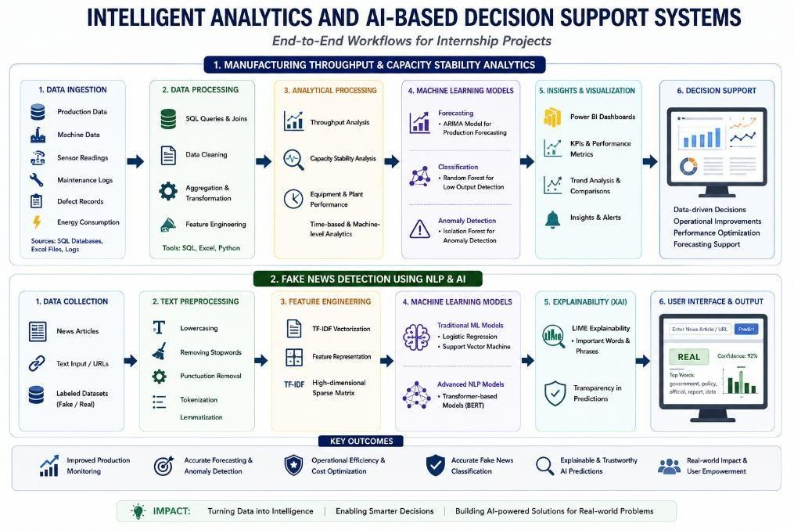

Figure 6.6: Workflow

Debugging and Problem Solving
A significant portion of the internship involved identifying, analyzing, and resolving real-time technical issues across data analytics, machine learning, NLP workflows, dashboard development, and deployment environments. Debugging in Data Science and AI systems is often more complex than traditional software development because errors can originate from multiple layers, including data preprocessing issues, SQL query failures, model performance limitations, dependency conflicts, integration mismatches, visualization errors, or deployment- related problems.
During the internship, I encountered and resolved a variety of issues, including:

    - Data Preprocessing Challenges: Situations where structured manufacturing data contained inconsistencies, missing values, formatting mismatches, or irrelevant records that affected analytical accuracy and machine learning model performance.
    - SQL Query and Data Aggregation Errors: Issues related to incorrect joins, aggregation mismatches, filtering logic errors, and structured data processing problems while generating analytical reports and performance summaries.
    - Machine Learning Model Performance Issues: Cases involving class imbalance, overfitting risks, feature engineering limitations, model tuning challenges, and prediction inconsistencies that required iterative optimization and validation.

    - NLP Processing Challenges: Issues in text preprocessing such as noisy textual content, dataset leakage concerns, tokenization inconsistencies, feature engineering errors, and classification pipeline debugging.
    - Dependency and Environment Conflicts: Challenges related to Python library compatibility, transformer model setup, package installation errors, notebook execution issues, and deployment environment configuration.
    - Dashboard and User Interface Issues: Problems involving Power BI visualization refinement, dashboard interaction behavior, KPI display formatting, and Gradio interface debugging for prediction output presentation.
Each debugging session followed a systematic professional approach: reproducing the issue, isolating the affected component, analyzing root causes, implementing corrective actions, optimizing the workflow, and validating the solution through testing and performance evaluation. This structured problem-solving approach significantly strengthened my analytical thinking, debugging discipline, and practical engineering mindset while working on real-world AI and Data Science systems.

Testing Experience
Testing is a critical discipline that ensures the reliability, correctness, performance, and usability of Data Science and AI-based systems. During the internship, I gained practical exposure to multiple testing methodologies while validating both the Manufacturing Throughput & Capacity Stability Analytics project and the Fake News Detection using NLP & AI project.
Manual Testing involved systematically validating project outputs to ensure that analytical workflows, dashboards, predictive models, and user-facing interfaces functioned as expected. For the manufacturing analytics project, this included verifying throughput calculations, forecasting outputs, anomaly detection results, SQL-generated reports, and Power BI dashboard behavior. For the fake news detection project, manual testing involved validating predictions for different article types, confidence score outputs, URL-based classification, explainability responses, and interface behavior under multiple input scenarios.

Model Performance Testing involved evaluating machine learning model effectiveness using appropriate performance metrics. For predictive analytics, forecasting accuracy was assessed using error-based evaluation metrics, while anomaly detection and fake news classification models were evaluated using Accuracy, Precision, Recall, F1 Score, and classification reports to ensure model reliability.
Workflow Validation involved testing complete end-to-end processing pipelines, ensuring that data moved correctly through preprocessing stages, feature engineering workflows, model inference pipelines, dashboard outputs, and deployed application interfaces without logical or technical failures.
Regression Testing involved re-validating previously functioning analytical workflows and prediction systems after making changes to preprocessing logic, feature engineering steps, model tuning, or interface refinements, ensuring that improvements did not unintentionally affect existing functionality.
This testing experience provided practical understanding of quality assurance in Data Science, analytics, and AI application development, while reinforcing the importance of systematic validation in delivering accurate, reliable, and user-trusted intelligent systems.

Domain Knowledge and Practical Analytical Understanding
Working on real-world industry-oriented projects required developing practical domain understanding beyond technical implementation. Without contextual knowledge of the application domain, interpreting analytical outputs and validating intelligent system performance would not be meaningful. The internship provided valuable exposure to both industrial manufacturing analytics and intelligent text classification systems.
Manufacturing Operations and Performance Metrics: The manufacturing analytics project required understanding industrial operational metrics such as throughput, capacity utilization, machine stability, maintenance frequency, defect rates, production efficiency, and energy consumption. Learning how these parameters influence production performance was essential for meaningful analytics and predictive decision support.
Predictive Maintenance and Anomaly Detection: Understanding how machine behavior, operational fluctuations, and abnormal production events indicate performance degradation was important for designing anomaly detection workflows and interpreting predictive outputs accurately.

Data-Driven Industrial Decision Support: Exposure to industrial analytics provided practical understanding of how structured operational data supports production monitoring, performance optimization, forecasting, and operational planning in real-world manufacturing environments.
Natural Language Processing and Text Intelligence: The fake news detection project required domain understanding of how textual information is processed, interpreted, and classified using NLP workflows. This included understanding linguistic preprocessing, contextual text analysis, and automated content classification.
Misinformation Detection and Explainable AI: Practical exposure was gained in understanding how fake news spreads through digital content, how machine learning systems identify misleading patterns, and how explainable AI improves trust by making classification decisions interpretable.
This domain knowledge significantly improved my ability to connect technical implementation with practical real-world problem-solving, making the internship experience both technically enriching and professionally meaningful. V

UI/UX Enhancements
An often underappreciated aspect of Data Science and AI application development is the design of user interfaces and visualization experiences. Even highly accurate analytical systems may fail to deliver practical value if users cannot easily interpret outputs or interact with the application effectively. During the internship, I gained practical exposure to improving visualization design, dashboard usability, and user interaction for both the manufacturing analytics and fake news detection projects.
Dashboard Improvements: For the Manufacturing Throughput & Capacity Stability Analytics project, interactive Power BI dashboards were designed and refined to present industrial insights in a clear and meaningful manner. This included improving the layout of KPI cards, trend charts, plant comparison visuals, stability metrics, and production performance indicators. Visual hierarchy was carefully structured to ensure that important operational insights such as total production, anomaly trends, machine performance, and capacity metrics were immediately visible to users.

Interactive Data Visualization: Efforts were made to make dashboard analytics more user-friendly through the use of filters, slicers, comparative visualizations, trend analysis charts, and intuitive KPI summaries. These enhancements improved usability and enabled efficient exploration of production data for decision-making purposes.
AI Application Interface Design: For the Fake News Detection using NLP & AI project, the Gradio-based web application interface was designed to provide a smooth and intuitive user experience. The interface allowed users to input article text or URLs easily, receive classification results in a readable format, view confidence scores, and understand prediction explanations through LIME outputs.
Output Presentation and Explainability Design: Special attention was given to presenting AI predictions in a clear, interpretable, and user-friendly format so that users could understand not only the classification result but also the reasoning behind the decision.
Usability and Interface Refinement: Interface layouts, content presentation, interaction flow, and visual clarity were refined through iterative improvements to ensure practical usability, readability, and efficient user interaction.
These UI/UX enhancements reinforced the understanding that successful AI and analytics systems require not only strong technical implementation but also effective visualization, intuitive interaction design, and user-centered thinking to maximize real-world usability and impact.

Learning Modern Tools and Technologies
The internship provided practical hands-on experience with a wide range of modern tools and technologies commonly used in Data Science, Machine Learning, Artificial Intelligence, Natural Language Processing, analytics, and application development:
Git and GitHub: Version control tools were used to manage project development, maintain code versions, organize project files, and track iterative progress during implementation. This provided practical exposure to professional development workflows and code management practices.

Python and Data Science Libraries: Python served as the core programming language for both projects. I gained practical experience using libraries such as Pandas and NumPy for data manipulation and analysis, Scikit-learn for machine learning model development, Matplotlib/visualization tools for analysis, and NLP-related libraries for text preprocessing and classification workflows.
SQL: Structured Query Language (SQL) was extensively used for extracting, filtering, aggregating, and analyzing structured industrial datasets. This provided practical understanding of analytical querying, data engineering, and structured reporting workflows.
Excel: Excel was used for exploratory data analysis, data cleaning, quick validation, performance analysis, and preliminary analytical workflows during the manufacturing analytics project.
Power BI: Power BI was used to design and develop interactive dashboards for manufacturing analytics, enabling KPI tracking, performance visualization, trend monitoring, and decision-support reporting.
Natural Language Processing and AI Frameworks: For the fake news detection project, practical exposure was gained in NLP workflows involving TF-IDF vectorization, machine learning classification, transformer-based architectures such as BERT and RoBERTa, and Explainable AI using LIME.
Gradio: Gradio was used for deploying the fake news detection model as an interactive web application, providing practical exposure to user-facing AI deployment and interface development.
Development Environments and Tools: Tools such as Jupyter Notebook, Google Colab, and Visual Studio Code (VS Code) were used for coding, experimentation, model training, debugging, and project implementation.
Web Data Handling Libraries: Libraries such as Requests and BeautifulSoup were used for handling URL-based content extraction in the fake news detection application.
AI-Assisted Development Tools: Modern AI-assisted coding tools were used to accelerate implementation, assist in debugging, explore solution approaches, and improve development productivity. Learning how to critically evaluate and adapt AI-generated assistance became a valuable modern technical skill.

This exposure to modern industry-standard tools significantly strengthened my practical technical proficiency and improved my readiness for real-world Data Science and AI development environments.

Team Collaboration and Communication

Technical expertise alone is not sufficient for professional success; effective communication, collaboration, and the ability to work within a professional environment are equally important. During the internship, I developed practical communication and professional coordination skills while working within an industry-oriented environment involving mentors, technical guidance, project reviews, and structured progress discussions.
Although the internship projects were completed as individual technical implementations, regular interaction with mentors and guidance sessions required clearly communicating project objectives, explaining technical approaches, discussing implementation challenges, presenting progress updates, and incorporating feedback into subsequent development stages. This improved my ability to explain technical concepts in a structured and professional manner, receive constructive input, and adapt my work based on recommendations.
Project presentations, technical discussions, debugging reviews, and result demonstrations also strengthened my communication confidence, documentation skills, and professional interaction abilities, all of which are essential in real-world technology environments.

Real-Time Project Workflow

Understanding how real-world Data Science and AI projects are structured and executed was one of the broader and most valuable learning outcomes of the internship. Unlike academic assignments that often focus only on final outputs, the internship provided practical exposure to the complete lifecycle of project development, from problem understanding to final implementation and validation.

Both projects followed a structured workflow involving problem definition, requirement understanding, data collection, preprocessing, exploratory analysis, feature engineering, model development, iterative debugging, performance evaluation, dashboard visualization or deployment, documentation, and final presentation preparation.
The Manufacturing Throughput & Capacity Stability Analytics project followed a workflow centered on industrial data analytics, SQL-based processing, predictive modeling, anomaly detection, and dashboard reporting. The Fake News Detection using NLP & AI project followed an end-to-end machine learning and deployment workflow involving text preprocessing, NLP feature engineering, classification modeling, explainable AI integration, interface development, and application testing. This structured real-world workflow provided valuable practical understanding of how technical skills in Data Science, Machine Learning, AI, and deployment fit into complete professional project development lifecycles, significantly improving my industry readiness and project execution discipline.
.

CHAPTER 7

LEARNING OUTCOMES

During the course of my internship at Digital Maven (Unit of Incanto Dynamics Pvt. Ltd.), working on Manufacturing Throughput & Capacity Stability Analytics and Fake News Detection using NLP & AI, I gained significant practical knowledge and hands-on experience across multiple technical and professional domains. The internship served as a highly transformative experience that converted academic concepts into practical, industry- relevant technical skills and strengthened my readiness for real-world Data Science and Artificial Intelligence roles.

Outcome 1: Strong Understanding of Data Science, Machine Learning, and AI Concepts

One of the most important outcomes of the internship was developing a strong practical understanding of Data Science, Machine Learning, Artificial Intelligence, and Predictive Analytics. Beyond theoretical academic knowledge, I gained real-world understanding of how intelligent systems are designed, how machine learning models are selected and implemented, how predictive analytics workflows operate, and how AI solutions are evaluated and optimized for practical use.

Outcome 2: Proficiency in Data Collection, Preprocessing, and Feature Engineering

The internship significantly strengthened my ability to independently handle structured and unstructured datasets. I gained practical expertise in data cleaning, normalization, transformation, feature engineering, text preprocessing, dataset preparation, and building machine learning-ready analytical pipelines, which are essential skills for any Data Science or AI role

Outcome 3: Practical Experience in Predictive Analytics and Machine Learning Model Development
Through the manufacturing analytics project, I developed hands-on experience in implementing forecasting models, anomaly detection systems, and classification workflows. I learned how predictive analytics supports industrial decision-making and gained confidence in building machine learning models for real-world analytical applications.

Outcome 4: Strong Knowledge of Natural Language Processing and Intelligent Text Classification
The fake news detection project provided practical expertise in Natural Language Processing (NLP), including text preprocessing, TF-IDF feature engineering, text classification, misinformation detection, and transformer-based language understanding. This significantly strengthened my understanding of AI-powered text intelligence systems.

Outcome 5: Experience with Explainable AI and Modern AI Architectures

The internship provided valuable exposure to advanced AI concepts such as BERT, RoBERTa, and Explainable AI using LIME. I developed practical understanding of how modern AI architectures process language and how explainability techniques improve model transparency, interpretability, and trustworthiness.

Outcome 6: Enhanced SQL and Data Engineering Skills

Working on industrial manufacturing analytics strengthened my SQL and structured data engineering capabilities. I gained practical experience in writing analytical queries, performing data aggregation, creating structured analytical tables, and organizing data workflows that support reporting and predictive analytics.

Outcome 7: Practical Dashboard Development and Business Intelligence Skills

The internship improved my ability to design professional data visualizations and interactive dashboards using Power BI. I gained practical understanding of KPI monitoring, comparative analysis, trend visualization, dashboard usability, and decision-support reporting.

Outcome 8: Strong Debugging, Testing, and Problem-Solving Abilities

A major outcome of the internship was the development of systematic debugging and technical problem-solving skills. Working through preprocessing issues, SQL errors, model tuning challenges, deployment conflicts, and workflow failures strengthened my analytical mindset and improved my ability to diagnose and resolve complex technical problems.

Outcome 9: Experience in AI Application Deployment

Through the fake news detection project, I gained practical experience in deploying machine learning systems as user-interactive web applications using Gradio, improving my understanding of AI deployment, interface integration, and real-world solution delivery.

Outcome 10: Familiarity with Modern Industry Tools and Technologies

The internship provided practical exposure to modern technologies including Python, SQL, Excel, Power BI, Scikit-learn, Transformers, PyTorch, LIME, Gradio, Jupyter Notebook, Google Colab, VS Code, Git, BeautifulSoup, and Requests. This significantly improved my technical readiness for professional Data Science and AI roles.

Outcome 11: Improved Professional Communication and Project Execution Skills

The internship strengthened my communication, technical documentation, presentation, and professional interaction skills. Regular project reviews, mentor discussions, technical demonstrations, and result presentations improved my confidence in communicating complex technical ideas clearly and professionally.

Outcome 12: Strong Industry Readiness and Practical Confidence

Collectively, the internship outcomes significantly improved my readiness for careers in Data Science, Machine Learning, Artificial Intelligence, NLP, Analytics, and Intelligent Application Development. The combination of technical expertise, real-world project implementation, problem-solving ability, and professional exposure provided a strong foundation for future industry opportunities.

CHAPTER 8

SNAPSHOTS
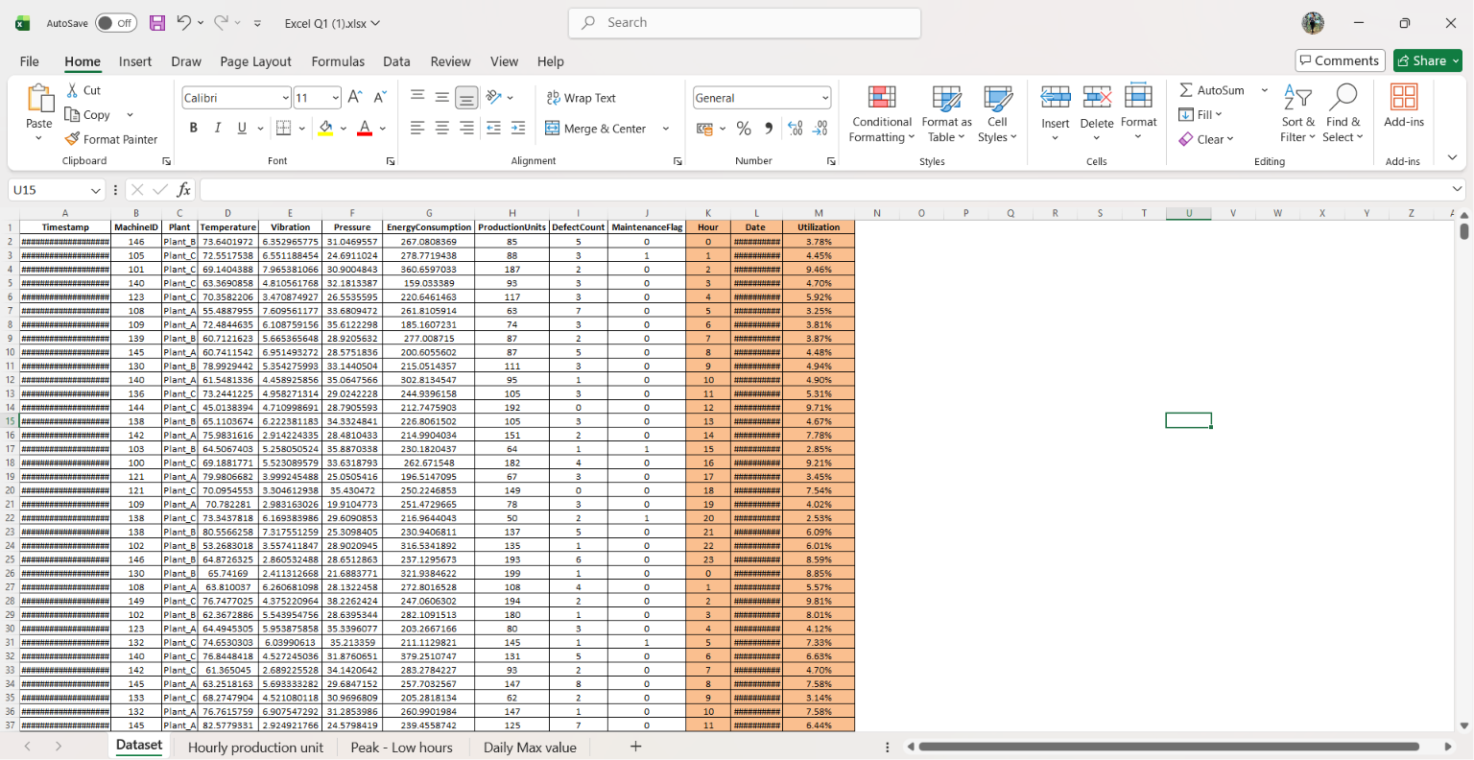
Figure 8.1: Dataset
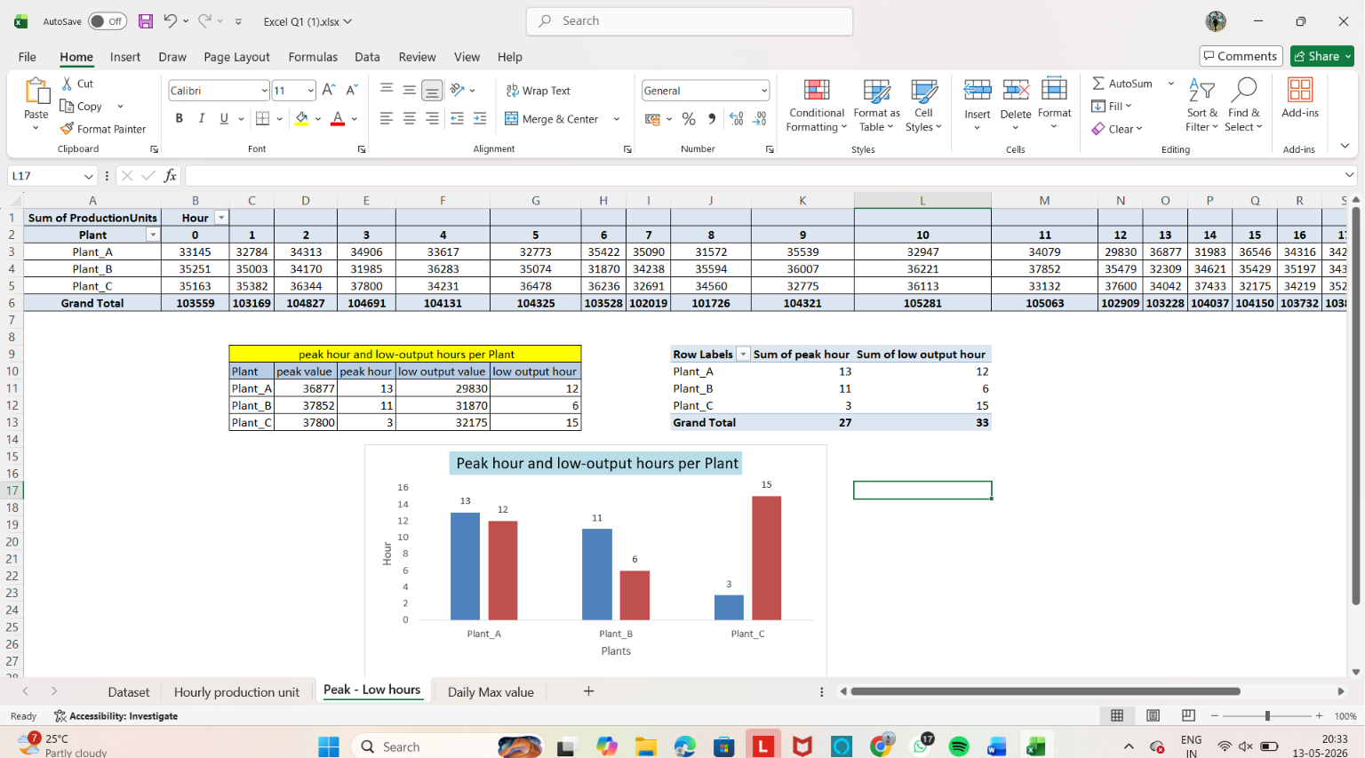
Figure 8.2 Excel Dashboard 1

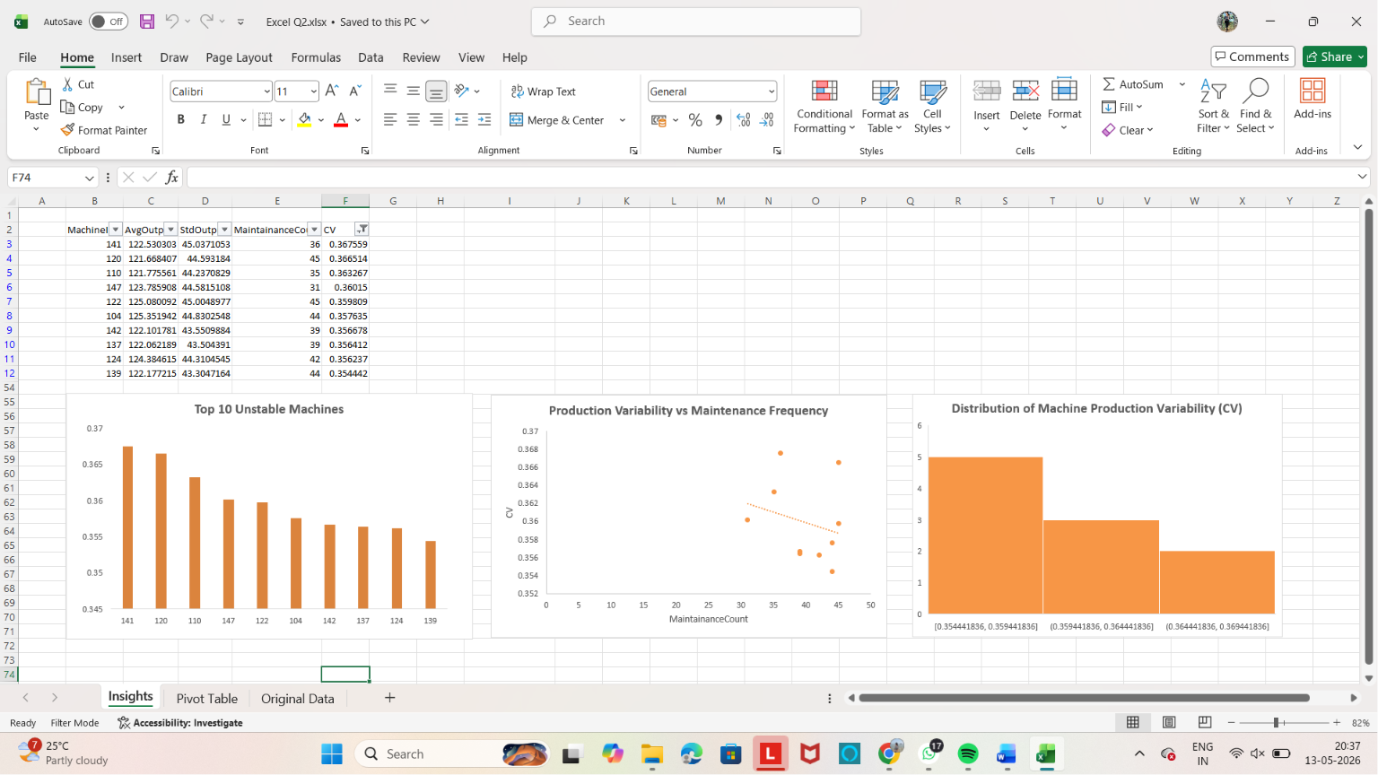
Figure 8.3 Excel Dashboard 2
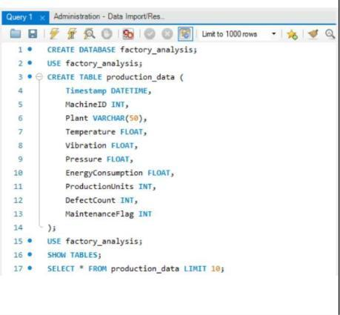
Figure 8.4: SQL Analysis 1

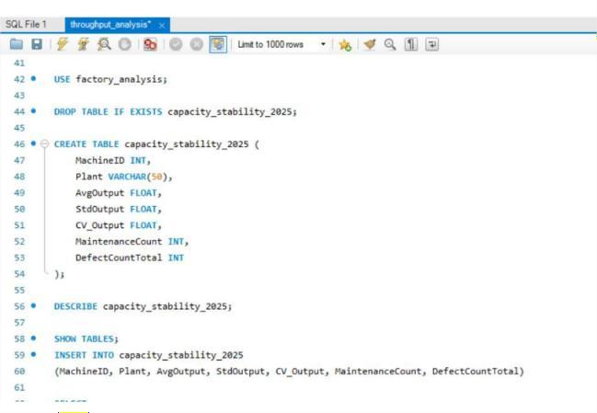
Figure 8.5 SQL Analysis 2
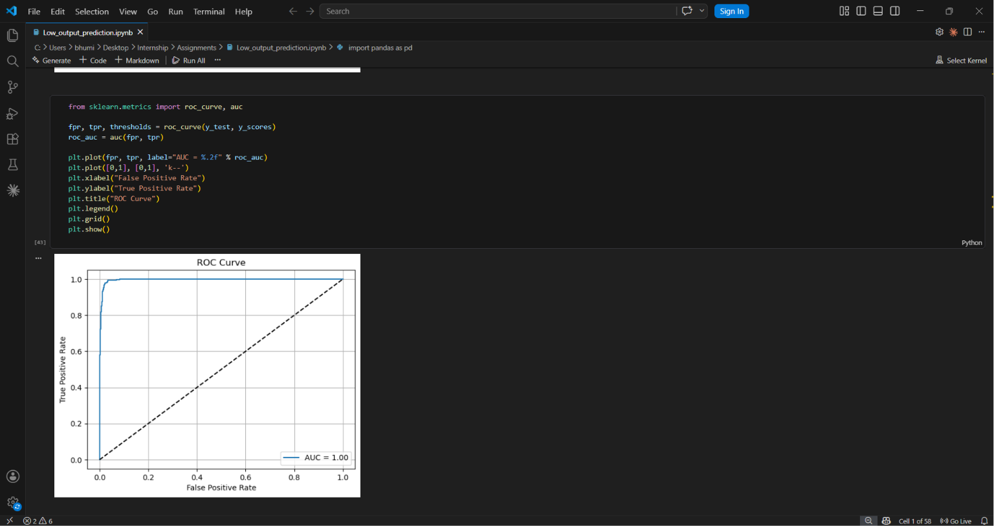
Figure 8.6 Python Analysis

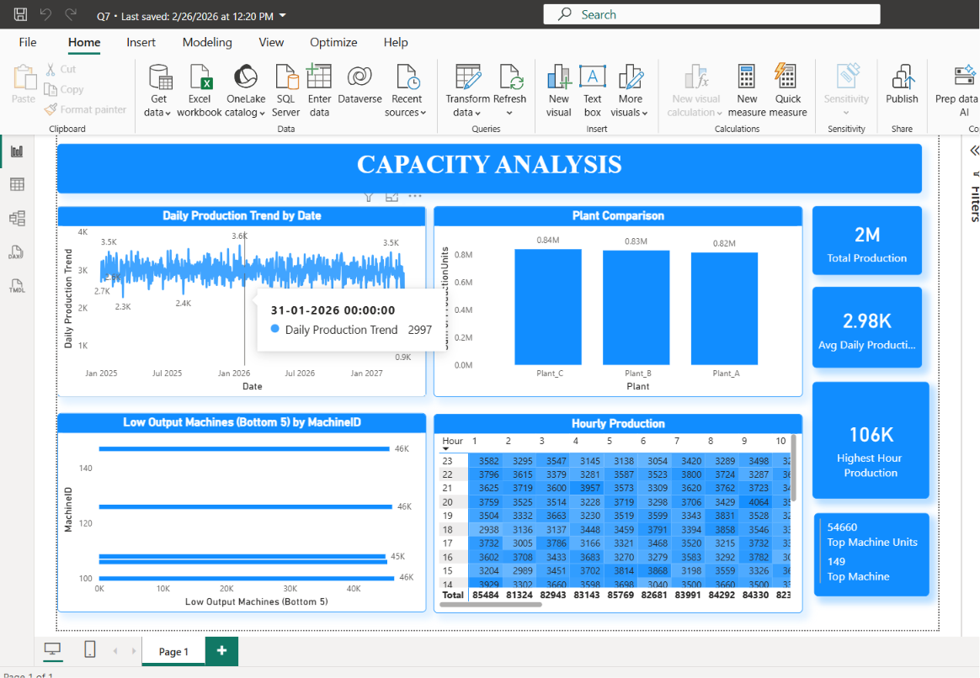
Figure 8.7 Power BI Dashboard 1

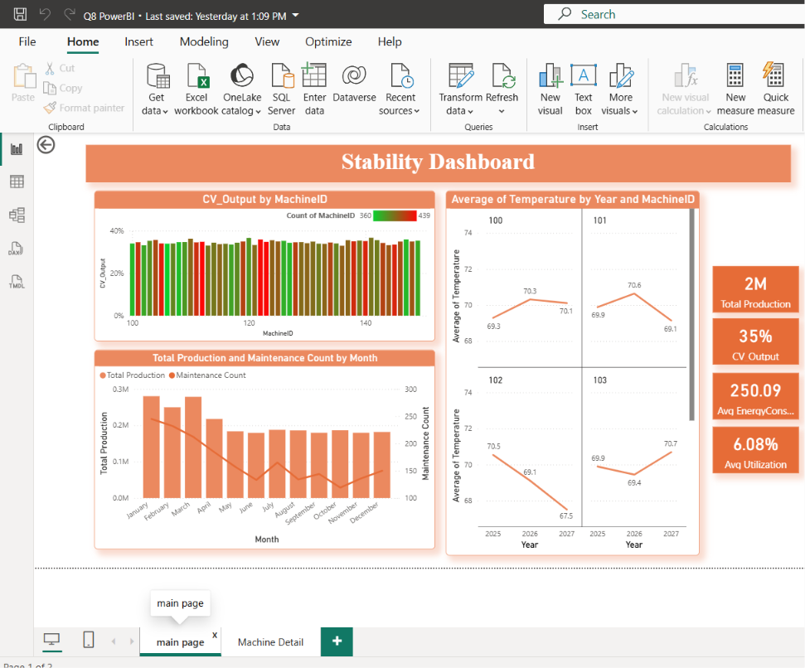
Figure 8.8 Powe BI Dashboard 2

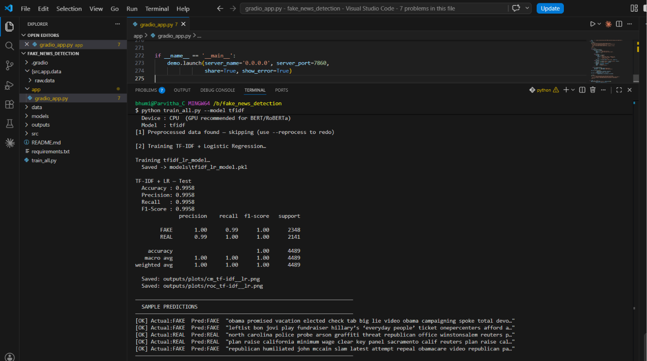
Figure 8.9 Fake news detection - Training TF-TDF
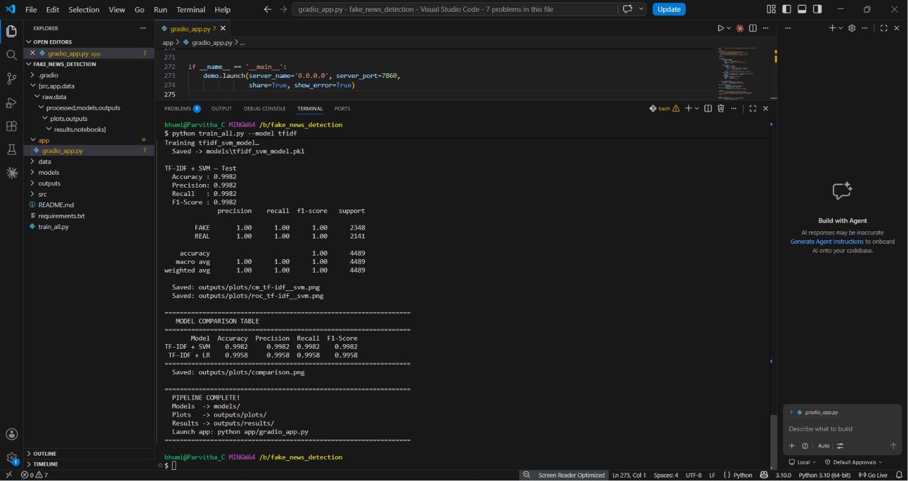
Figure 8.10 Fake news detection - Training SVM

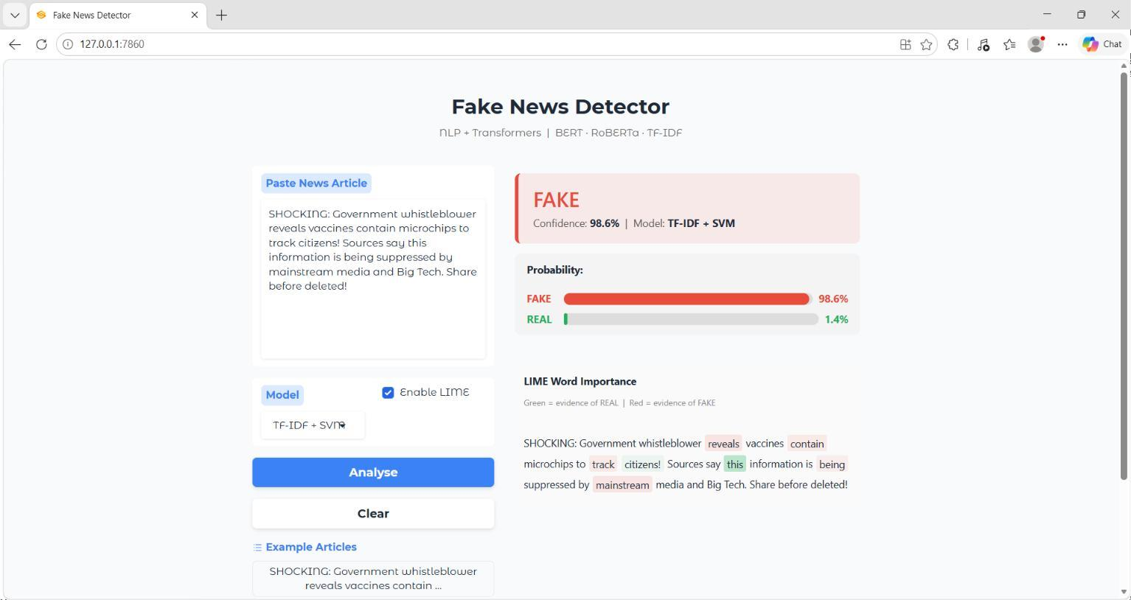

Figure 8.11 Fake news detector UI

CHAPTER 9

FUTURE SCOPE

The internship at Digital Maven (Unit of Incanto Dynamics Pvt. Ltd.) demonstrated the practical application of Data Science, Artificial Intelligence, Machine Learning, Predictive Analytics, and Natural Language Processing in solving real-world industrial and information-centric problems. The development of the Manufacturing Throughput & Capacity Stability Analytics system and the Fake News Detection using NLP & AI application serves as a strong foundation for future intelligent decision-support systems. As industries increasingly adopt AI-driven technologies, the scope for expanding these solutions is substantial, ranging from real-time industrial automation to advanced misinformation detection ecosystems.

Real-Time Predictive Manufacturing Analytics
While the current manufacturing analytics project focused on historical performance analysis, forecasting, and anomaly detection using static datasets, future enhancements can transform the system into a real-time predictive industrial intelligence platform.
  - Predictive Maintenance Systems: Future implementations can integrate live IoT sensor streams from industrial equipment to detect machine degradation patterns before failures occur.
  - Real-Time Anomaly Alerts: Instead of post-analysis anomaly identification, future systems can trigger instant alerts when unusual production drops, abnormal sensor readings, or performance instability are detected.
  - Production Optimization Intelligence: Advanced machine learning models can recommend production scheduling improvements, machine utilization balancing, and process optimization strategies based on historical and live performance data.

Advanced Industrial AI and Smart Manufacturing Integration
The manufacturing analytics framework can evolve into a more comprehensive smart factory intelligence system.
  - IoT-Integrated Industrial Monitoring: Integration with industrial IoT infrastructure can enable continuous monitoring of temperature, vibration, pressure, energy usage, and machine performance.

  - Automated Decision Support Systems: AI-powered recommendation systems can support plant managers with intelligent operational suggestions based on predictive insights.
  - Scalable Multi-Plant Analytics: The current plant-wise analysis can be expanded into enterprise-level monitoring across multiple manufacturing facilities.

Advanced Fake News Detection and NLP Intelligence
The fake news detection application provides a strong baseline for intelligent misinformation detection, but future improvements can significantly expand its real-world impact.
  - Transformer-Based Production Deployment: Advanced transformer architectures such as fully optimized BERT, RoBERTa, DistilBERT, or multilingual transformer models can replace lightweight classical pipelines for deeper contextual understanding.
  - Multilingual Fake News Detection: Future systems can expand beyond English to support multiple languages, enabling broader misinformation detection capabilities.
  - Context-Aware Fact Verification: Integration with trusted news APIs, fact-checking databases, and real-time information retrieval can improve verification accuracy.

Explainable AI and Trustworthy Decision Systems
The Explainable AI integration provides a strong starting point for trustworthy AI systems.
  - Advanced Explainability Dashboards: Future versions can provide richer interpretability visualizations, confidence explanations, and decision transparency reports.
  - Bias Detection and Fairness Monitoring: Additional AI governance mechanisms can monitor model bias, reliability, and fairness in classification decisions.
  - User Trust Enhancement: More transparent AI explanations can improve confidence and adoption among end users.

Scalable AI Application Deployment
The current Gradio-based fake news detection system demonstrates successful deployment, but future scalability can be significantly improved.
  - Cloud-Based Deployment: Migration to scalable cloud infrastructure for broader accessibility and production readiness.
  - REST API Integration: Deployment as reusable APIs for integration into websites, mobile apps, or enterprise systems.

  - Browser Extension Development: A browser-based fake news detection assistant for real- time web article verification.
  - Mobile Application Support: Cross-platform mobile deployment for practical end-user accessibility.

Intelligent Human-AI Interaction
Future AI systems can become more interactive, adaptive, and user-friendly.
  - Voice-Based Interaction: Voice-enabled fake news verification assistants for accessibility and convenience.
  - Interactive Industrial Dashboards: AI-driven conversational analytics interfaces for querying industrial performance data naturally.
  - Adaptive User Feedback Systems: Systems that learn from user interactions to improve prediction quality and usability over time.

Research and Industry Expansion
The technical foundation developed during this internship can support broader research and commercial applications.
  - Advanced Time-Series Forecasting Research: Exploring deep learning models such as LSTM, GRU, Prophet, or Transformer-based forecasting for manufacturing analytics.
  - Hybrid NLP Classification Models: Combining classical ML with transformer architectures for improved fake news detection performance.
  - Enterprise AI Solutions: Scaling both projects into enterprise-ready intelligent decision- support platforms.

Career and Technical Growth
The internship has also established a strong technical foundation for future academic and professional growth.
  - Advanced specialization in Data Science, Machine Learning, Artificial Intelligence, NLP, and Explainable AI
  - Application of these skills in larger real-world analytics, automation, and intelligent software systems.
  - Readiness for future research, higher education, and professional roles in AI-driven industries.

CONCLUSION

The internship at Digital Maven (Unit of Incanto Dynamics Pvt. Ltd.) was a highly enriching and professionally transformative experience that provided valuable practical exposure to the real-world applications of Data Science, Machine Learning, Artificial Intelligence, Natural Language Processing, Business Intelligence, and intelligent application development. This internship successfully bridged the gap between theoretical academic knowledge and practical industry implementation by providing hands-on experience in solving meaningful, industry-oriented technical problems through structured project development.
Throughout the internship, I had the opportunity to work on two major real-world projects: Manufacturing Throughput & Capacity Stability Analytics and Fake News Detection using NLP & Artificial Intelligence. These projects exposed me to a wide range of modern technologies, development methodologies, analytical workflows, and intelligent system design practices, enabling me to understand the complete lifecycle of Data Science and AI solution development.
The Manufacturing Throughput & Capacity Stability Analytics project provided deep practical exposure to industrial analytics, structured data engineering, predictive modeling, anomaly detection, and dashboard-driven business intelligence. Working with real manufacturing datasets helped me understand how operational data can be transformed into meaningful insights for monitoring performance, identifying inefficiencies, forecasting future trends, and supporting data-driven industrial decision-making. The experience strengthened my practical understanding of structured data handling, SQL analytics, machine learning model development, forecasting methodologies, and dashboard visualization using Power BI.
The Fake News Detection using NLP & AI project offered significant exposure to intelligent text analytics, machine learning-based classification, explainable AI, and real-world AI deployment. Through this project, I gained practical knowledge of Natural Language Processing workflows, text preprocessing, TF-IDF feature engineering, classification algorithms such as Logistic Regression and Support Vector Machines, transformer-based architectures such as BERT and RoBERTa, and explainability techniques using LIME.

Beyond technical implementation, the internship significantly strengthened my problem-solving abilities, debugging discipline, analytical thinking, model evaluation skills, project execution capabilities, documentation practices, and professional communication skills. Real-world technical challenges such as preprocessing complexity, SQL debugging, machine learning optimization, NLP workflow management, deployment issues, and interface refinement provided valuable opportunities to develop systematic engineering problem-solving approaches.
The internship also improved my familiarity with modern industry-standard tools and technologies, including Python, SQL, Excel, Power BI, Scikit-learn, Transformers, PyTorch, LIME, Gradio, Jupyter Notebook, Google Colab, Git, BeautifulSoup, and Requests, significantly improving my technical readiness for future industry roles.
A particularly valuable aspect of the internship was understanding that successful Data Science and AI systems require more than just accurate models—they require reliable data pipelines, structured workflows, thoughtful system integration, effective visualization, explainability, testing, usability, and deployment readiness. This practical understanding provided a much broader perspective on how intelligent systems are designed and delivered in professional environments.
Overall, this internship served as a highly valuable learning journey that transformed academic concepts into practical technical competence. It strengthened my confidence, expanded my professional perspective, and significantly improved my readiness for future careers in Data Science, Machine Learning, Artificial Intelligence, Natural Language Processing, Analytics, and intelligent software development. The knowledge, experience, and skills gained during this internship will serve as a strong foundation for my future academic pursuits, research opportunities, and professional growth in the rapidly evolving technology industry.

REFERENCES

Python Official Documentation
https://docs.python.org/3/
Reference for Python programming, data processing, machine learning implementation, and application development workflows.

Pandas Official Documentation
https://pandas.pydata.org/docs/
Used for structured data manipulation, preprocessing, filtering, aggregation, and analytical data handling.

NumPy Official Documentation
https://numpy.org/doc/
Reference for numerical computing, array operations, and mathematical transformations.

Scikit-learn Official Documentation
https://scikit-learn.org/stable/
Used for machine learning model implementation, preprocessing, feature engineering, and evaluation.

Microsoft Power BI Documentation
https://learn.microsoft.com/en-us/power-bi/
Reference for dashboard development, KPI reporting, and business intelligence analytics.

MySQL Documentation
https://dev.mysql.com/doc/
Used for SQL query development, structured data processing, and analytical reporting.

Jupyter Notebook Documentation
https://jupyter.org/documentation
Reference for interactive Python experimentation and project development.

Google Colab Documentation
https://colab.research.google.com/
Used for cloud-based model training and experimentation.

Hugging Face Transformers Documentation
https://huggingface.co/docs/transformers
Reference for transformer architectures including BERT and RoBERTa.

PyTorch Documentation
https://pytorch.org/docs/stable/index.html
Used for deep learning and transformer implementation support.

LIME Documentation
https://lime-ml.readthedocs.io/
Reference for Explainable AI implementation.

Gradio Documentation
https://www.gradio.app/docs
Used for fake news detection web application deployment.

- BeautifulSoup Documentation https://www.crummy.com/software/BeautifulSoup/bs4/doc/ Reference for web scraping and article content extraction.

Requests Documentation
https://requests.readthedocs.io/
Used for HTTP requests and web data retrieval.

- ISOT Fake News Dataset https://www.uvic.ca/engineering/ece/isot/datasets/fake-news/index.php Dataset source used for fake news detection training and evaluation.

ATTACHMENTS
